St. John the Baptist Quasi Parish, Batoka, Diocese of Monze
Borehole Project
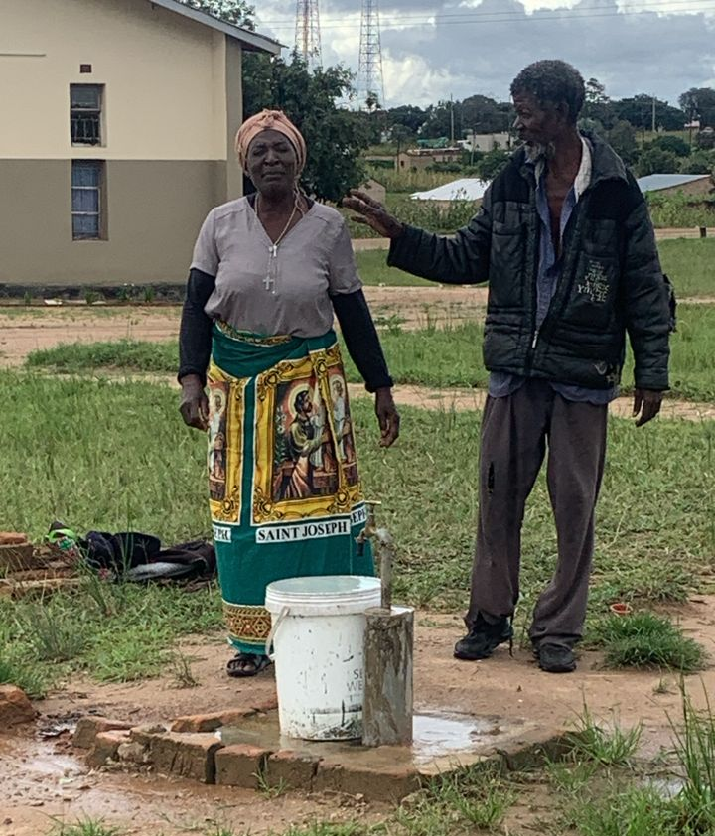
Happy parishioners
